

Major Project End-Term Report

Project Title: UpTrend
A Web-Based Trading Education and Paper Trading Platform

Submitted By
Name | SAP ID | Specialization
Aditya Narayan Gour | 500106985 | B Tech CSE Graphics and Gaming
Divya Joshi | 500107118 | B Tech CSE Graphics and Gaming

School of Computer Science
University of Petroleum & Energy Studies, Dehradun

 11th May 2026
Project Mentor Signature Date of Submission

CANDIDATE’S DECLARATION

I/We hereby certify that the project work entitled “UpTrend” in partial fulfilment of the requirements for the award of the Degree of BACHELOR OF TECHNOLOGY in COMPUTER SCIENCE AND ENGINEERING with specialization in Graphics and Gaming and submitted to the Department of Systemics, School of Computer Science, University of Petroleum & Energy Studies, Dehradun, is an authentic record of my/ our work carried out during a period from January, 2026 to April,2026 under the supervision of Dr Keshav Sinha.

The matter presented in this project has not been submitted by me/ us for the award of any other degree of this or any other University.

Divya Joshi

R2142220320

Aditya Narayan Gour

R2142220404

This is to certify that the above statement made by the candidate is correct to the best of my knowledge.
Date: 11th May 2026 Dr Keshav Sinha
Project Guide

ACKNOWLEDGEMENT

We wish to express our deep gratitude to our guide Dr Keshav Sinha, for all advice, encouragement and constant support he has given us throughout our project work. This work would not have been possible without his support and valuable suggestions.
We sincerely thanks to our respected Dr Keshav Sinha, for his great support in doing our project in UpTrend.
We are also grateful to Dean SoCS UPES for giving us the necessary facilities to carry out our project work successfully. We also thanks to our Course Coordinator, Ms. Rahat Naaz and our Activity Coordinator Mr. Alind, for providing timely support and information during the completion of this project.
We would like to thank all our friends for their help and constructive criticism during our project work. Finally, we have no words to express our sincere gratitude to our parents who have shown us this world and for every support they have given us.

Divya Joshi | Aditya Narayan Gour
R2142220320 | R2142220404

TABLE OF CONTENT
Sr. No. | Title
1. | Abstract
2. | Introduction
3. | Problem Statement & Objectives
4. | Literature Review
5. | System Architecture
6. | Methodology & Implementation
7. | Software Requirements
8. | Results & Final Output
9. | Testing & Validation
10. | Scope & Limitations
11. | Future Work
12. | Conclusion
13. | References

- ABSTRACT
Many novices have been enticed to engage in trading activities without the necessary training or real-world experience due to the quick expansion of online financial markets and digital trading platforms. The majority of inexperienced traders rely on disjointed learning materials like blogs, videos, and social media posts, which frequently lack organization and real-world application. As a result, when novices enter genuine trading environments, they frequently encounter uncertainty, emotional decision-making, and financial losses.
In order to close the knowledge gap between theoretical financial education and real-world market experience, UpTrend is a web-based instructional and paper trading platform. The software integrates a real-time paper trading simulator, interactive tests, portfolio tracking, and structured learning modules into a single ecosystem. With virtual money, users may learn trading principles and put them to use right away in a risk-free setting.
The MERN stack—which includes MongoDB, Express.js, React.js, and Node.js—as well as Tailwind CSS for responsive UI design are used in the development of the application. Modules including user authentication, trading simulation, performance analytics, instructional content, and portfolio management are all part of the platform.
UpTrend's main objective is to give novices a secure and engaging setting where they can learn about market behavior, develop their trading discipline, and gain confidence before engaging in actual financial markets. The project shows how to successfully combine financial simulation software with contemporary web technologies to produce a scalable and intuitive learning environment.
- INTRODUCTION
The quick development of digital technology and online brokerage systems has made financial markets more accessible. Through web and mobile platforms, people may now immediately engage in financial analysis, cryptocurrency investing, and stock trading. While this accessibility has opened up new avenues for financial expansion, it has also presented serious obstacles for novices.
The majority of novice traders enter the financial markets without having a solid grasp of risk management, trading discipline, or market behavior. Online learning materials are frequently disorganized and dispersed across several platforms, which makes it challenging for students to get a methodical grasp of financial concepts. Users frequently enter live trading situations without any prior experience, which can result in emotional decision-making and financial losses.

Traditional methods of financial education focus heavily on theoretical explanations while lacking practical implementation. However, trading is a skill that requires experience, observation, analysis, and continuous practice. Without a safe environment for experimentation, beginners struggle to gain confidence and understand real-world market dynamics.
UpTrend was developed as a solution to this problem by integrating financial education with practical simulation. The platform provides a structured learning ecosystem where users can:
- Learn trading concepts through educational modules
- Complete quizzes to test understanding
- Practice trading using virtual money
- Analyze their performance through analytics dashboards
The project's main goal is to provide an environment that is accessible to beginners and encourages learning before execution. Rather of promoting direct involvement in real-time financial markets, UpTrend uses guided educational information and paper trading to help consumers progressively gain confidence.
Through flexible interfaces, performance tracking, gamified progress systems, and contemporary dashboard design, the platform also prioritizes user engagement. UpTrend helps novices become more financially literate and practice responsible trading by fusing education, simulation, and analytics.
3. PROBLEM STATEMENT & OBJECTIVES
Problem Statement
Due to a lack of formal educational instruction and actual exposure, novice traders frequently encounter several challenges while joining the financial markets. Current learning systems don't let users apply concepts in real-world trading scenarios; instead, they mostly offer theoretical knowledge. In a similar vein, a lot of trading systems prioritize execution over novices' instructional needs.
Some major challenges faced by beginner traders include:
- Lack of practical trading experience
- High financial risk in live markets
- Emotional trading decisions
- Absence of performance tracking systems
- Fragmented educational resources
- Difficulty understanding market behavior
These challenges create the need for a unified platform that combines education, simulation, and analytics into a single ecosystem.

Objectives
The major objectives of the UpTrend project are:
- To develop a paper trading simulator using virtual money
- To provide structured educational modules for beginners
- To implement portfolio management and profit/loss tracking
- To create interactive dashboards for analytics and monitoring
- To ensure secure user authentication and data management
- To improve financial literacy through practical learning
- To create a responsive and beginner-friendly user interface
The project aims to reduce the gap between theoretical learning and practical market understanding through simulation-based education.

4. LITERATURE REVIEW
The fast expansion of online financial markets has made financial literacy and simulation-based learning far more important in recent years. Scholars and specialists in educational technology have highlighted the necessity of systems that integrate theoretical knowledge with real-world implementation.
Simulation-Based Learning (SBL) is one of the most talked-about methods in finance education. According to studies, simulations give students the chance to practice making difficult decisions in secure settings without having to deal with the repercussions of real-world situations. Paper trading platforms give novices the chance to learn about market movement, risk management, and portfolio management without suffering financial loss.
The psychological difficulties of trading are also highlighted by research on financial behavior. Beginner traders are frequently influenced by emotions like fear, greed, and overconfidence, which lead to rash choices and inconsistent tactics. According to a number of studies, trading notebooks and performance analytics can assist users in recognizing behavioral errors and gradually strengthening their discipline.
In contemporary educational institutions, interactive dashboards and data visualization tools have also grown in significance. Large volumes of dynamic data are involved in financial markets, which can be challenging for novices to understand. By making complex numerical data easier to understand, visualization tools like graphs, charts, and portfolio analytics enhance comprehension.
Another significant idea studied in educational technology research is gamification. Features that boost user interest and promote regular participation include quizzes, progress monitoring, achievements, and levels. Gamification can help users stay motivated while progressively honing their skills in trade education systems.
Because of their performance and versatility, modern web technologies like MongoDB, Node.js, and React.js are being used more and more for scalable real-time applications. Applications built using the MERN stack are especially well suited for interactive systems that need responsive interfaces, secure authentication, and constant updates.
While there are a number of paper trading systems, the most lack integrated educational support and only concentrate on simulation. In a similar vein, educational platforms frequently fall short of offering genuine, hands-on settings in which to apply concepts. Systems like UpTrend, which integrate learning, simulation, and analytics on a single platform, are made possible by this gap.
The effectiveness of integrating simulation systems, visualization tools, and organized learning settings to enhance financial literacy and practical decision-making abilities is well supported by the literature.

5. SYSTEM ARCHITECTURE
System Overview:
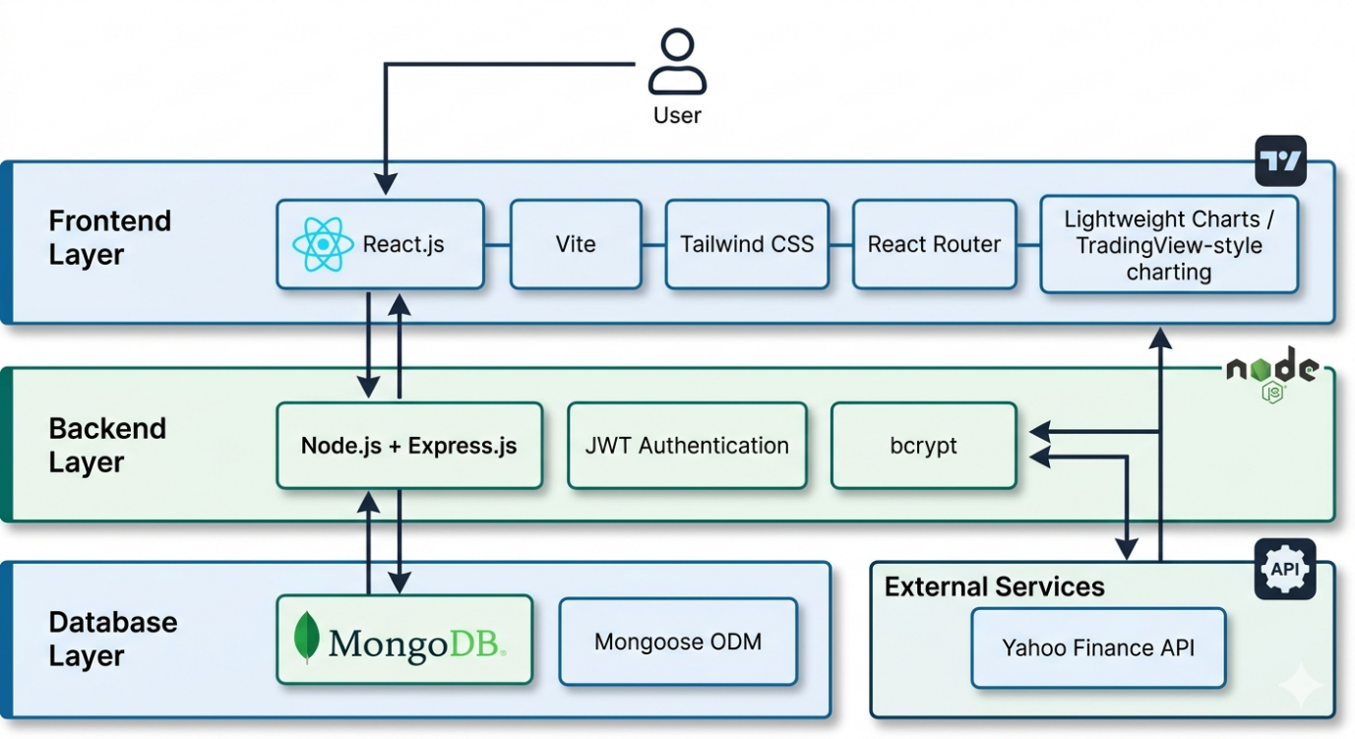
Fig 1: System Architecture of UpTrend

The UpTrend platform follows a three-tier architecture consisting of:
1. Frontend Layer
The frontend is developed using React.js and Tailwind CSS. This layer handles:
- User interface rendering
- Dashboard visualization
- Navigation between modules
- User interaction and responsiveness
2. Backend Layer
The backend is developed using Node.js and Express.js. It manages:
- Business logic
- Authentication systems
- Trading simulation logic
- API communication
- Portfolio calculations
3. Database Layer
MongoDB is used as the primary database for storing:
- User profiles
- Trade history
- Portfolio information
- Quiz progress
- Educational data
4. External Financial APIs
Financial APIs such as Yahoo Finance are integrated to fetch:
- Real-time stock prices
- Market updates
- Asset-related data
Core Modules
The major modules implemented in UpTrend include:
- User Authentication System
- Trading Simulator
- Portfolio Management
- Educational Academy
- Quiz & Assessment System
- Analytics Dashboard

6. METHODOLOGY & IMPLEMENTATION
UpTrend was developed using a modular and iterative methodology. The project was split up into phases for database administration, frontend development, backend integration, and testing.
Front-end Programming
React.js was used to build the frontend because of its efficient rendering capabilities and component-based architecture. To design a contemporary and responsive user interface, Tailwind CSS was utilized for styling.
Features implemented in the frontend include:
- Responsive dashboards
- Trading interface
- Educational modules
- Charts and analytics
- Portfolio visualization

Backend Development
Node.js and Express.js were used to implement server-side logic. The backend handles:
- Authentication
- Trade execution
- Portfolio updates
- Profit/loss calculations
- Data retrieval
JWT-based authentication was implemented to ensure secure session management.

Database Management
MongoDB was used because of its flexibility and scalability. Collections were created for:
- Users
- Trades
- Holdings
- Learning progress
- Quiz results

Trading Simulation Logic
The trading engine allows users to:
- Buy assets
- Sell assets
- Track holdings
- Monitor virtual balance
Portfolio values are updated dynamically using market price data.

Educational Module
The academy section provides:
- Structured learning paths
- Topic-based lessons
- Interactive quizzes
- Progress tracking
Users are encouraged to complete educational modules before participating in simulated trading.

7. SOFTWARE REQUIREMENTS
Development Tools
- Visual Studio Code
- Git & GitHub
- Postman
Technologies Used
- React.js
- Node.js
- Express.js
- MongoDB
- Tailwind CSS
APIs & Libraries
- Yahoo Finance API
- Recharts
- JWT Authentication
- Axios
Hardware Requirements
- Minimum 8GB RAM
- Internet Connectivity
- Modern Web Browser

8. RESULTS & FINAL OUTPUT
The final implementation of UpTrend successfully demonstrates all planned functionalities and modules.

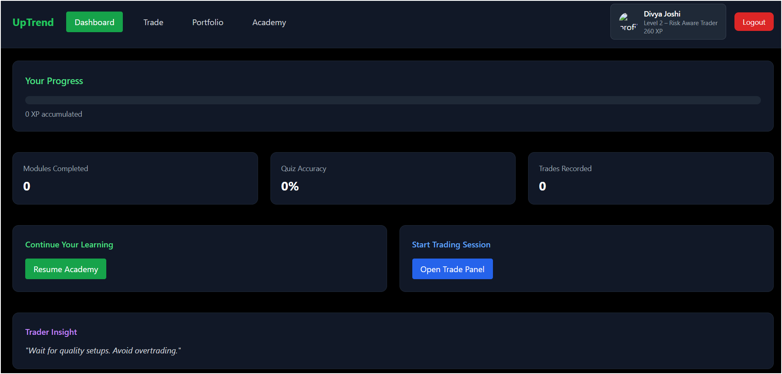
Fig 2: Dashboard
The dashboard displays:
- Trading capital
- Win rate
- Total trades
- Portfolio overview
- User activity analytics

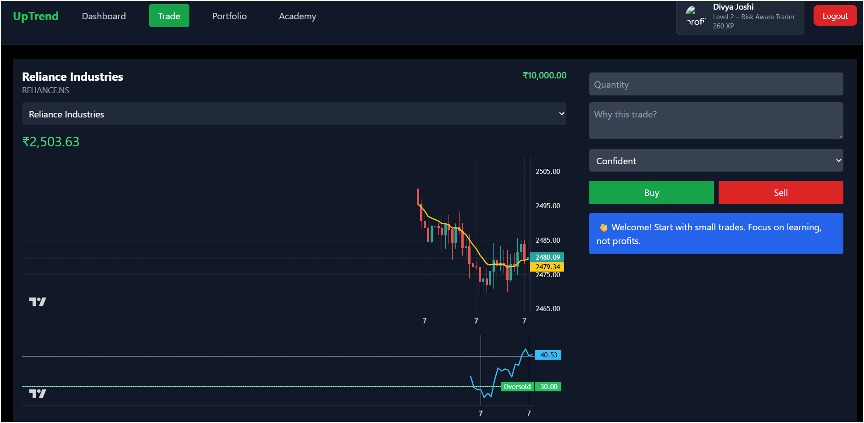
Fig 3: Trade Section
The trading section allows users to:
- Simulate buying/selling
- Monitor stock prices
- Execute paper trades
- Track virtual investments

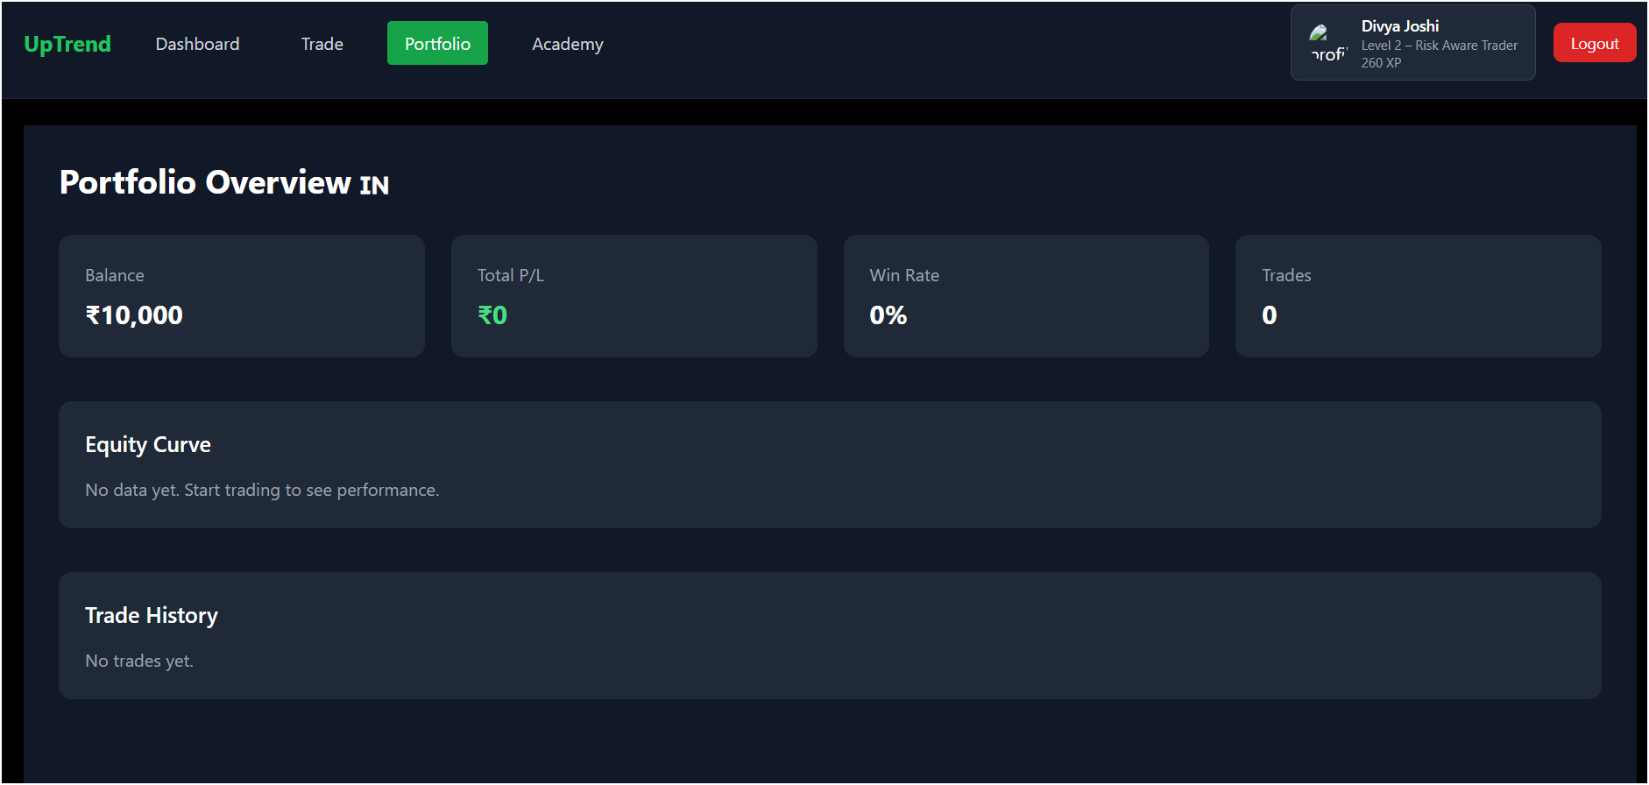
Fig 4: Portfolio Section
The portfolio module provides:
- Holdings overview
- Profit/Loss tracking
- Investment balance
- Asset allocation

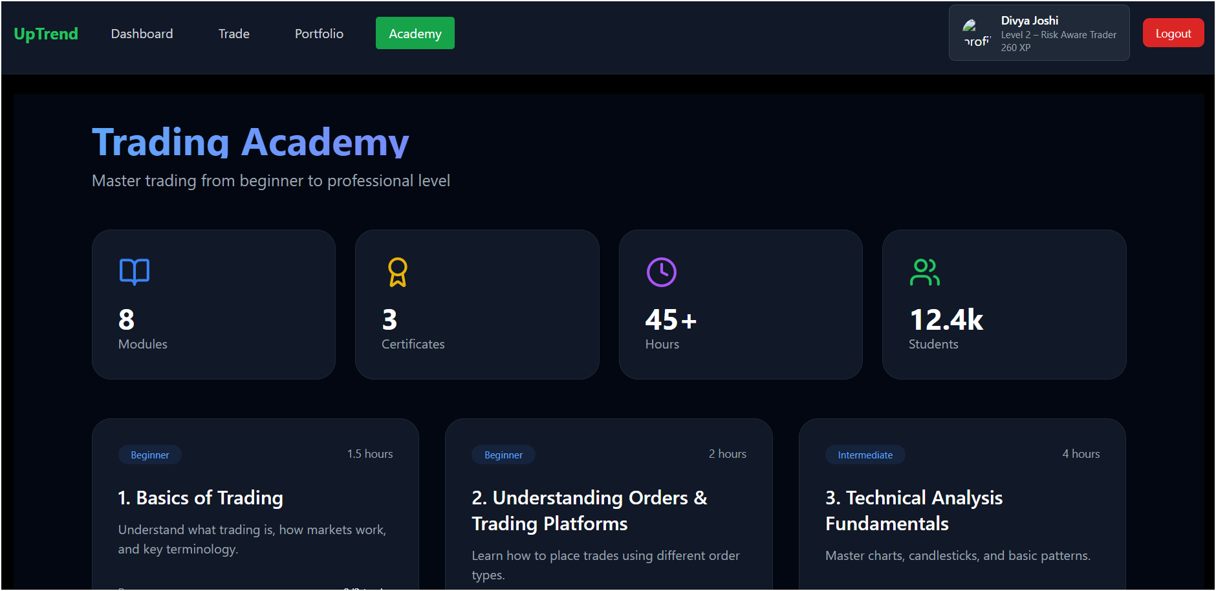
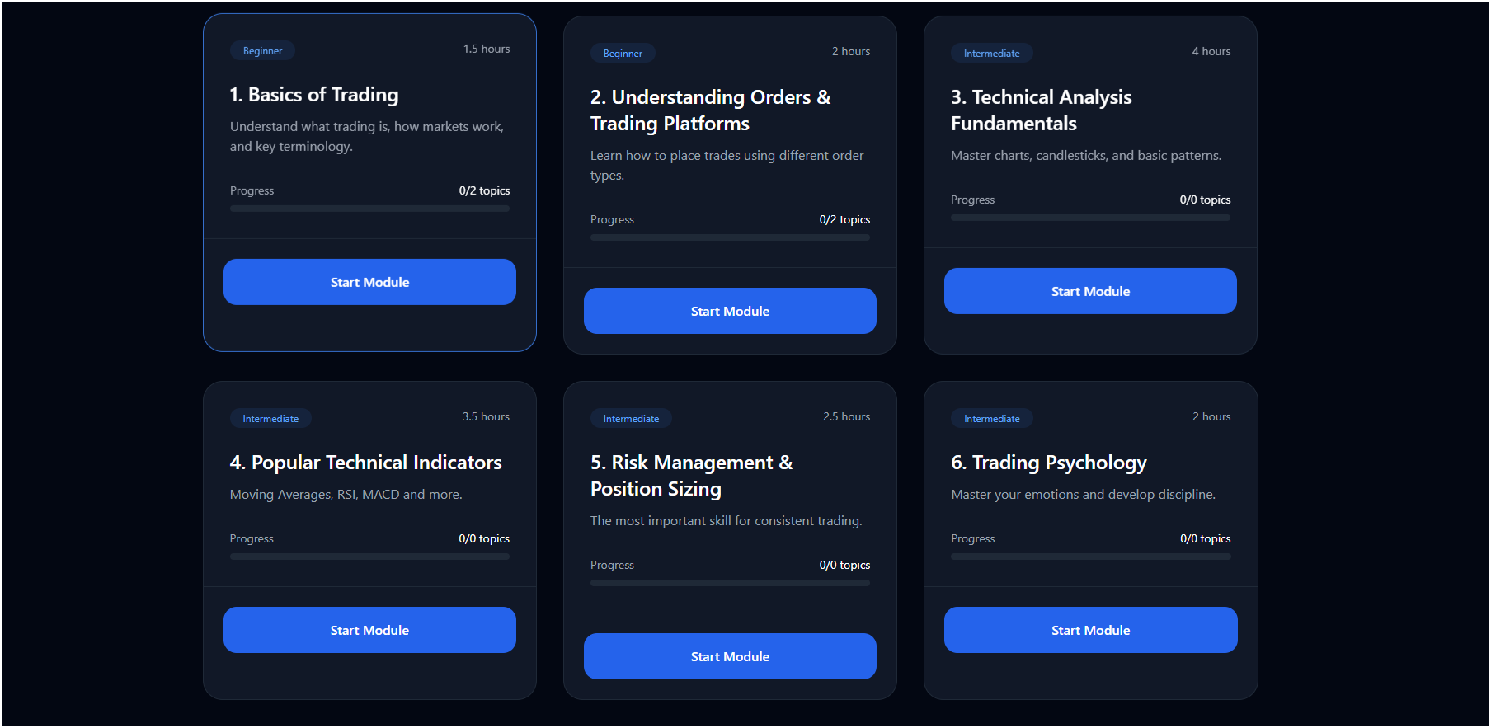
Fig 5: Academy Section

The academy module includes:
- Beginner trading concepts
- Market fundamentals
- Risk management lessons
- Interactive learning material
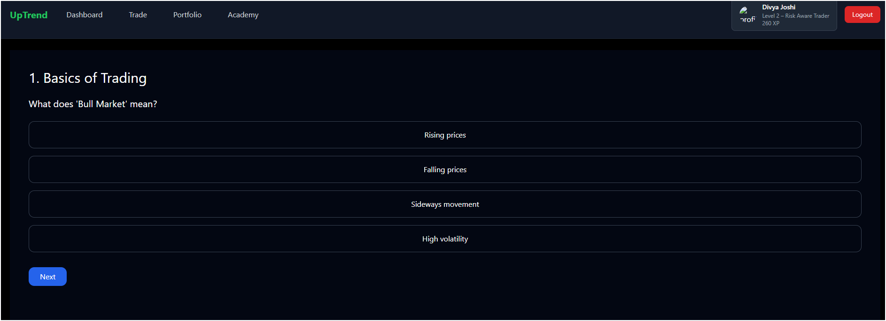
Fig 6: The quiz section validates user understanding before allowing progression to advanced modules.

9. TESTING & VALIDATION
Several testing methods were used during development to ensure system stability and functionality.
Testing Performed
Unit Testing
Verified correctness of:
- Profit/loss calculations
- Trade execution
- Portfolio updates
Integration Testing
Ensured smooth communication between:
- Frontend and backend
- APIs and database
UI Testing
Tested:
- Responsiveness
- Navigation
- User experience
Edge Case Testing
Handled:
- Invalid trades
- Empty portfolios
- Incorrect authentication attempts
The platform demonstrated stable performance and accurate functionality during testing.

10. SCOPE & LIMITATIONS
Scope
The scope of UpTrend includes:
- Financial education
- Trading simulation
- Portfolio analytics
- Beginner learning systems
The platform is designed mainly for educational purposes and beginner training.

Limitations
Some limitations of the project include:
- No live trading integration
- Possible delay in market data
- Limited advanced trading features
- Cannot fully replicate emotional pressure of real trading

11. FUTURE WORK
Several enhancements can be added in future versions of UpTrend:
- AI-powered trading assistant
- Real-time live trading integration
- Social trading community features
- Advanced technical indicators
- Leaderboards and competitions
- Mobile application support
These improvements can further enhance user engagement and learning experience.

12. CONCLUSION
UpTrend effectively illustrates how trading simulation and financial education may be combined into a single web-based platform. By offering a secure and engaging setting for practice and learning, the project tackles the difficulties encountered by novice traders.
The software creates a comprehensive, user-friendly ecosystem by integrating analytics, paper trading, portfolio management, and organized educational content. Users can enhance their comprehension of market behavior, trading discipline, and decision-making abilities without taking on financial risk by using simulation-based learning.
Additionally, the project demonstrates how to create scalable and responsive applications using contemporary web technologies like React.js, Node.js, Express.js, and MongoDB. All things considered, UpTrend is a useful and significant strategy for raising financial literacy and encouraging responsible market participation.

13. REFERENCES
- Arshad, M., & Zaman, N. (2024). The Impact of Virtual Trading Simulators on Financial Literacy of Undergraduate Students. Journal of Financial Education & Technology, 12(3), 45–59.
- Bhanuse, R. S., et al. (2023). E-Learning Course Recommendation Using Content Filtering and Sentiment Analysis. Grenze International Journal of Engineering and Technology, 9(2), 112–125.
- Chen, L., & Lin, H. (2023). Bridging the Theory-Practice Gap: Simulation-Based Learning in FinTech Pedagogy. Educational Technology Research and Development, 71(2), 210–228.
- de Koning, B. B., et al. (2024). Learning with Visualizations Helps: A Meta-Analysis of Visualization Interventions in Financial Mathematics. Educational Research Review, 100639.
- Dixon, R. J., et al. (2024). Mitigating Emotional Biases in Retail Trading through Digital Trade Journals. Behavioral Finance Review, 9(1), 102–118.
- Gupta, S., & Varma, A. (2025). Scalability and Performance Analysis of MERN Stack Applications in Real-Time Financial Monitoring Systems. International Journal of Web Engineering, 15(4), 334–350.
- Kaufman, D., & Saunders, C. (2023). Gamification in Wealth Management: Interactive Dashboards and Investment Discipline. Journal of Digital Learning, 18(2), 88–105.
- Kolagar, Z., Steindl, S., & Zarcone, A. (2023). Eduquick: Evaluating Summarization of Educational Content for Social Media Learning. Proceedings of the 4th Workshop on NLP Systems, 34–43.
- Lee, K. M., & Wong, S. (2024). The Efficacy of Real-Time Feedback in Paper Trading Platforms. FinTech Education Quarterly, 6(3), 15–32.
- Patel, R. (2023). Modern UI/UX Trends in Financial Dashboards Using Tailwind CSS and React. Journal of Software Design and Development, 21(1), 40–55.
- Sudirman, S., et al. (2025). Personalization of Interactive Teaching Materials in Digital Learning Systems. Journal of Curriculum Studies Research, 7(1), 152–178.
- Williams, T., & Brown, M. (2023). Self-Regulated Learning Strategies in Online Trading Communities. Review of Educational Research, 93(4), 512–530.
- React.js Official Documentation. Available at:
React Documentation
- Node.js Official Documentation. Available at:
Node.js Documentation
- MongoDB Official Documentation. Available at:
MongoDB Documentation
- Express.js Official Documentation. Available at:
Express.js Documentation
- Tailwind CSS Official Documentation. Available at:
Tailwind CSS Documentation
- Yahoo Finance API Documentation. Available at:
Yahoo Finance API
- Recharts Official Documentation. Available at:
Recharts Documentation
- JWT Authentication Documentation. Available at:
JWT Documentation
- Axios HTTP Client Documentation. Available at:
Axios Documentation
- GitHub Documentation. Available at:
GitHub Documentation
- MDN Web Docs – REST APIs and Web Development. Available at:
MDN Web Docs

